Anuj Saraswat (Product Leader, Innefu Labs)

Version – 0.1

Date: June 03, 2025

Interface Design Document

Intelligent Fusion Centre

# 1. Introduction

## 1.1 Purpose

This Interface Design Document outlines the user interface (UI) and user experience (UX) specifications for the Intelligent Fusion Center, based on the provided functional requirements outlined in sections 3.1.1 through 3.1.14 of the SRS. It serves as a detailed guide for UI/UX designers, developers, and stakeholders to understand and implement the system's interactive components.

## 1.2 Scope

This document covers the UI/UX design for the following modules and functionalities:

* Data Ingestion Pipelines
* Multilingual OCR
* Search Tool
* Workflow Automation
* Geospatial Analysis Module
* Temporal Analysis Module
* Graph Analysis Module
* Predictive Module
* IMINT Module
* Widgets
* Report Generation
* AI/LLM Model

It does *not* cover internal implementation details of each component or interfaces with external systems.

## 1.3 Definitions and Acronyms

* **IDD:** Interface Design Document
* **BDR:** Big Data Repository
* **OCR:** Optical Character Recognition
* **IMINT:** Imagery Intelligence
* **GIS:** Geospatial Information System
* **LLM:** Large Language Model
* **API:** Application Programming Interface
* **JSON:** JavaScript Object Notation
* **XML:** eXtensible Markup Language
* **HTTP:** Hypertext Transfer Protocol
* **HTTPS:** Hypertext Transfer Protocol Secure
* **UI:** User Interface
* **UX:** User Experience
* **RHS:** Right-Hand Side (panel)
* **LHS:** Left-Hand Side (panel)

## 1.4 References

* Link to Functional Requirements Document

# 2. System Overview

This system is a comprehensive data processing and analytics platform designed to handle document ingestion, analysis, and visualization while adhering to key non-functional requirements. It integrates multiple modules to process data from ingestion through advanced analytics and reporting. The core functional components (3.1.1 through 3.1.14) form a modular architecture where data flows sequentially or in parallel, depending on the workflow.

Key components include:

* **Data Ingestion Pipelines:** Handles the intake of raw data from external sources.
* **Multilingual OCR:** Extracts text from ingested documents, supporting multiple languages.
* **Big Data Repository:** Stores and manages large-scale data for quick access and querying.
* **Search Tool:** Enables users to query and retrieve data from the repository.
* **Workflow Automation:** Orchestrates the overall process, automating sequences and dependencies between components.
* **Text Analytics:** Analyzes extracted text for insights, such as sentiment or keyword extraction.
* **Geospatial Analysis Module:** Processes location-based data for spatial insights.
* **Temporal Analysis Module:** Examines time-based patterns in data.
* **Graph Analysis Module:** Handles network or relationship-based data analysis.
* **Predictive Module:** Uses historical data to forecast trends.
* **IMINT Module:** Handles IMINT data for ingestion and visualization.
* **Widgets:** Display data visualizations or interactive dashboards.
* **Report Generation:** Compiles and formats outputs from various modules into reports.
* **AI/LLM Model:** Leverages artificial intelligence, such as large language models, for advanced processing (e.g., natural language understanding).

The system operates as a pipeline: Data enters through ingestion, is processed and analysed, and outputs are generated for searching, visualization, or reporting. Workflow Automation coordinates these steps, while the AI/LLM Model enhance multiple modules.

*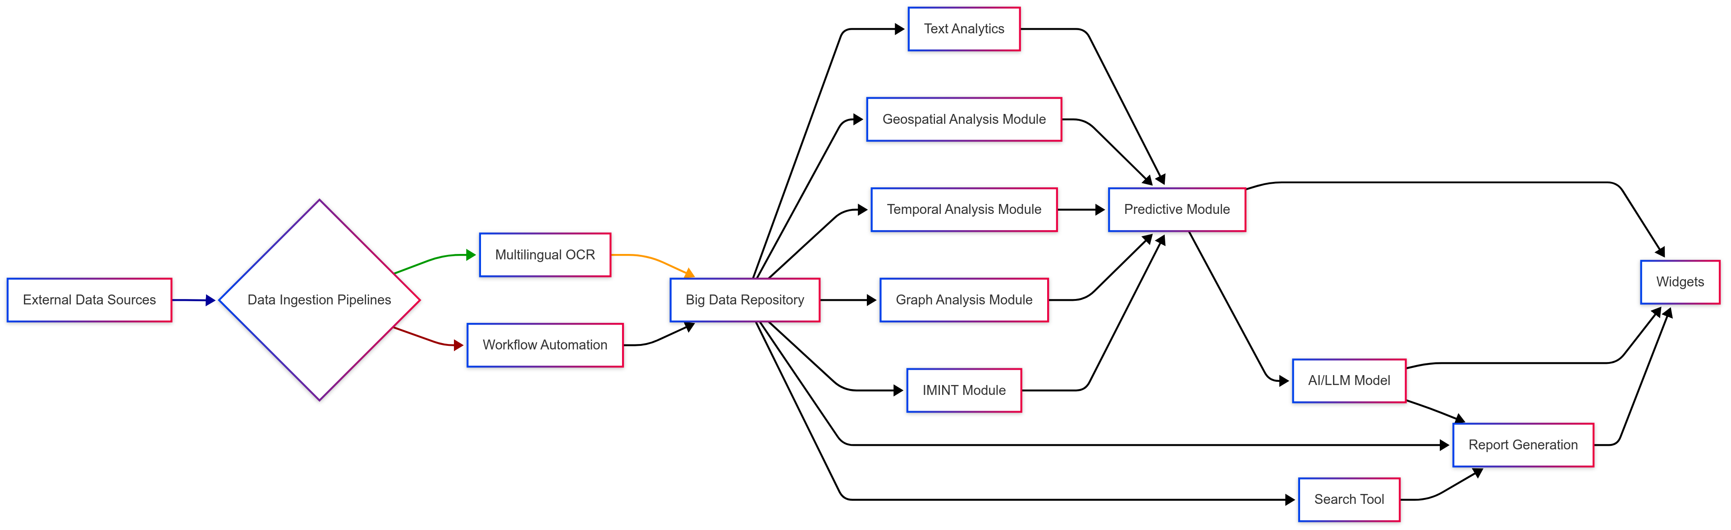Figure 2-1: High-Level Component Interaction Diagram*

**Diagram Explanation:**

* **Nodes:** Each box represents a component (e.g., “Data Ingestion Pipelines”).
* **Arrows:** Indicate data or control flow (e.g., from Data Ingestion to OCR).
* **Hub Structure:** The Big Data Repository is central, as it’s a common data store.
* **Parallel Paths:** Analytics modules (e.g., text, gsi, temporal, graph, imint) can run in parallel, feeding into the Predictive Module.
* **End Points:** Widgets and Report Generation are user-facing, drawing from processed outputs.

# 3. UI/UX design Principles

## 3.1 General Design Philosophy

* **Intuitive:** Easy to understand and use, minimizing learning curve.
* **Efficient:** Streamlined workflows to enable users to complete tasks quickly.
* **Consistent:** Uniform design patterns, navigation, and terminology across all modules.
* **Informative:** Clear feedback, status updates, and error messages.
* **Scalable:** Design should accommodate growth in data volume and feature set.

## 3.2 Navigation Structure

* **Main Navigation Bar (Global):** Persistent top/side navigation for core modules (e.g., Analysis, Workspace, AI/LLM, Dictionary, Alerts, Dashboard, File Work).
* **Module-Specific Navigation:** Sub-navigation or tabbed interfaces within specific modules for distinct functionalities (e.g., Dashboard, Search, Map, Chart, Graph, Reports, File Work).
* **Contextual Menus:** Right-click menus for actions on specific items (e.g., "Add to Timeline," "Add to Link-Analysis,").

## 3.3 Error Handling and Feedback

* **Inline Validation:** Immediate feedback for invalid input in forms.
* **Toast Notifications:** Non-intrusive messages for success, warning, or minor errors.
* **Modal Dialogs:** For critical errors or actions requiring user confirmation.
* **Detailed Error Logs (for System/Admin):** Backend logging for technical issues.
* **Clear Messages:** User-friendly language, avoiding technical jargon.

## 3.4 Accessibility Considerations

* **Keyboard Navigation:** All interactive elements should be keyboard accessible.
* **Color Contrast:** Sufficient contrast ratio for text and interactive elements.
* **Screen Reader Compatibility:** Semantic HTML and ARIA attributes where necessary.
* **Scalable Text:** Users should be able to adjust font sizes.

## 3.5 Responsiveness Strategy (General)

* **Fluid Grids:** Layouts adapt to screen width.
* **Flexible Images/Media:** Images scale to fit containers.
* **Media Queries:** CSS rules applied based on-screen size/device.
* **Breakpoint Definitions:** Standard breakpoints for multi-resolution desktops.
* **Content Prioritization:** Essential content displayed prominently on smaller screens; secondary content may be collapsed or moved.

# 4. Interface Definitions

This section details the user interfaces with use cases for each core components of IFC.

The system will provide a comprehensive web-based user interface designed for ease of use and efficient interaction.

## 4.1 Module: Data Ingestion

* **Overview:** The application should provide an interface to import data from multiple sources such as databases, documents into the Big Data Repository.
* **Key Screens/Interfaces:**

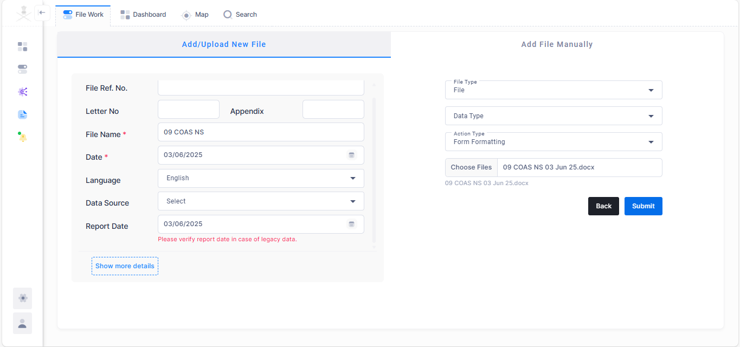

*Figure 4-1: Data Ingestion interface*

* **Data Flow Description:** Data Ingestion sends raw or pre-processed document data (e.g., image files, PDF pages) along with relevant metadata to the Multilingual OCR component for text extraction.

1. The user navigates to the "File Work" module and click on the ‘Create’ button for data ingestion. Add the mandatory fields like file, name, report date, file type for the datasets (file or databases) you wish to ingest.
2. **Configure Pipeline:**
   * **For File-based sources:** The user specifies the file path(s) or directory, file naming conventions.
   * **Select Source Type:** The user chooses the data source type from a list:
     + Excel File (FR-ING-001.1)
     + Microsoft Access Database (FR-ING-001.2)
     + Access Database (FR-ING-001.3)
     + Scanned Documents (FR-ING-001.4)
     + Digital Document Files (e.g., PDF, Word) (FR-ING-001.5)
   * **For Database sources (SQL):** The user provides connection details (server address, database name, credentials), and defines any filtering criteria needed.
3. **Execute Ingestion:**
   * The user clicks "submit" to initiate the ingestion process immediately.
   * The system implicitly maps the ingested data to the Big Data Repository.
4. **Ingestion Status:** The system displays a fadeout message with ingestion results.
5. **Address Errors (if any):** If failures occur, the user can review the logs, identify the root cause, and take corrective actions (e.g., correct source data) and re-run the ingestion.

**Alternative Flows:**

1. **Ingestion fails due to connectivity issues:** The system logs a connection error, and the user is notified.
2. **Ingestion fails due to data format issues:** The system logs data parsing errors, and the user is notified.

**Postconditions:**

* Data from the specified source is ingested into the system's Big Data Repository.

**4.2 Module: Multilingual OCR**

* **Overview:** Accurately extract text from scanned documents in multiple languages (such as English, Hindi, Mandarin) for further processing.
* **Key Screens/Interfaces:**

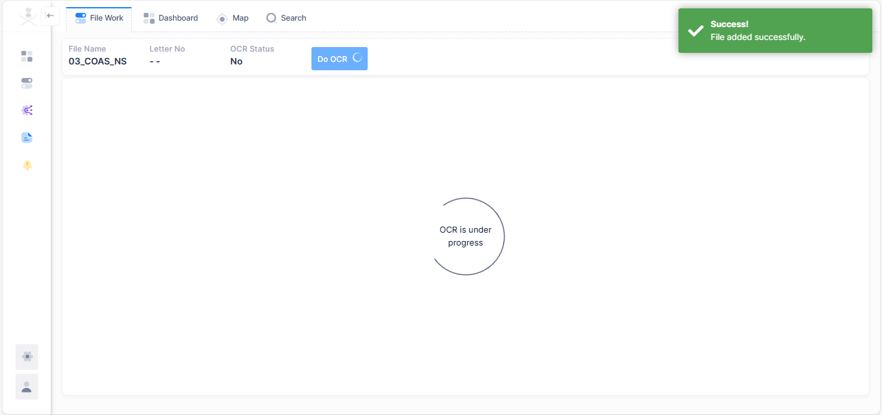

*Figure 4-2: OCR interface*

* **Data Flow Description:** Multilingual OCR sends the extracted text, detected language(s), confidence scores, and associated metadata (including the original document ID) to the Big Data Repository for persistent storage and indexing.

1. **OCR Trigger:** Upon successful ingestion of a scanned document image, the system automatically triggers the OCR module.
2. **Language Detection (Implicit/Configurable):** The OCR module (or an upstream component) attempts to detect the language(s) present in the document. Alternatively, the ingestion pipeline configuration might allow specifying the expected language.
3. **Text Extraction:** The OCR module processes the documents pixel by pixel, recognizing characters and converting them into machine-readable text.
4. **Language-Specific Processing:** Based on detected or configured language, the OCR module applies language-specific recognition models (e.g., English, Hindi, Mandarin character sets and linguistic rules).
5. **Text Output Generation:** The extracted text is generated and associated with the original scanned document. This may include positional information for each recognized word/character.
6. **OCR Error Review (Optional):**
   * A Data Reviewer can access the document in a review interface, displaying both the original image and the extracted text.
   * The Data Reviewer manually corrects any inaccuracies in the extracted text.
7. **Store OCR Output:** The corrected (or uncorrected) OCR text is stored in the Big Data Repository, linked to the original document image.

**Alternative Flows:**

* **Incorrect language detection:** If the OCR module incorrectly detects the language, leading to poor extraction, a Data Reviewer can manually override the extracted text.

**Postconditions:**

* Scanned document image has associated extracted text.
* Extracted text is stored in the Big Data Repository.
* OCR errors are minimized, or a mechanism for correction is provided.

**4.3 Module: Search Tool**

* **Overview:** Enable users to efficiently search and retrieve relevant information from the unified data repository using various search capabilities.
* **Key Screens/Interfaces:**

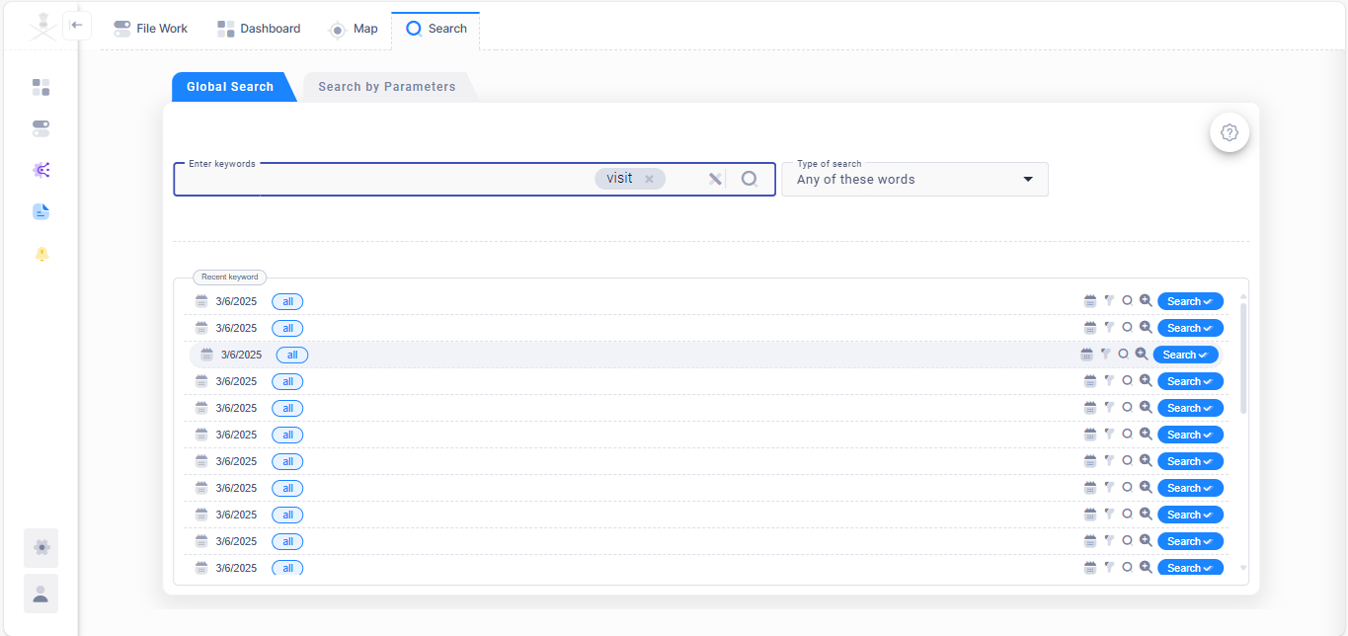

*Figure 4-3.1: Global Search and Search by Parameter interface*

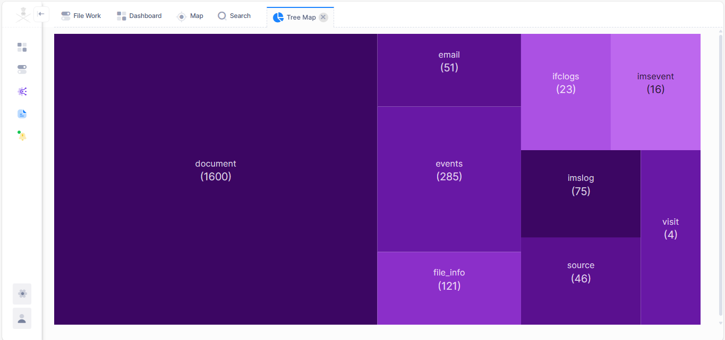

*Figure 4-3.2: Search Result Interface: Tree Map*

*Figure 4-3.3: Search Result Interface: Data Grid*

* **Data Flow Description:**

1. **Search Indexing:** Upon data ingestion or update, the system automatically imports relevant data into a search index for optimized retrieval.
2. **Access Search Interface:** The user navigates to the "Search" module.
3. **Global Search (360 search):**
   * Enable user search specific keywords or group of keywords to get all events related to those keywords.
4. **Search by Parameter (Basic Search):**
   * The user sees a search form with structured fields representing common data attributes (e.g., document, events, allorbat).
   * The user enters criteria into one or more fields.
   * The user clicks "Search."
5. **Search by Parameter (Advanced Search):**
   * The user selects the "Advanced Search" option.
   * Any of these
   * All of these
   * None of these
   * **Boolean:** The user enters search terms using Boolean operators (AND, OR, NOT).
   * **Proximity:** The user enters terms and specifies a maximum word distance.
   * **Fuzzy:** The user enters a search term with a fuzzy indicator (e.g., "receiept~" for "receipt").
   * The user clicks "Search".
6. **Display Search Results:** The system presents a list of search results as tree-map.
   * A tree map indicates the searched keywords present in all indexes with the record volume in repository
   * Onclick of a specific index of interest, a data-grid view containing all search results in a tabular form gets appeared in a New Tab.
   * For each selected result, a RHS panel popups which clearly display its source (e.g., "Excel: unit2_intell.xls," "Document: report.docx").
7. **Refine/Sort Results:** The user can further refine results using filters (e.g., by date, source, document type) or sort them by relevance, date, or other attributes.
8. **View Full Document/Record:** The user clicks on a search result to view the full document or record from the Big Data Repository.

**Alternative Flows:**

* **No results found:** The system informs the user that no results match the criteria.
* **Permission-based results:** The system only displays results that the logged-in user is authorized to view.

**Postconditions:**

* User can efficiently find relevant information across the entire data repository.
* Search results are accurate, relevant, and clearly presented.

**4.4 Module: Workflow Automation**

* **Overview:** Automate complex data processing tasks by defining multi-stage workflows, including review and approval mechanisms.
* **Key Screens/Interfaces:**

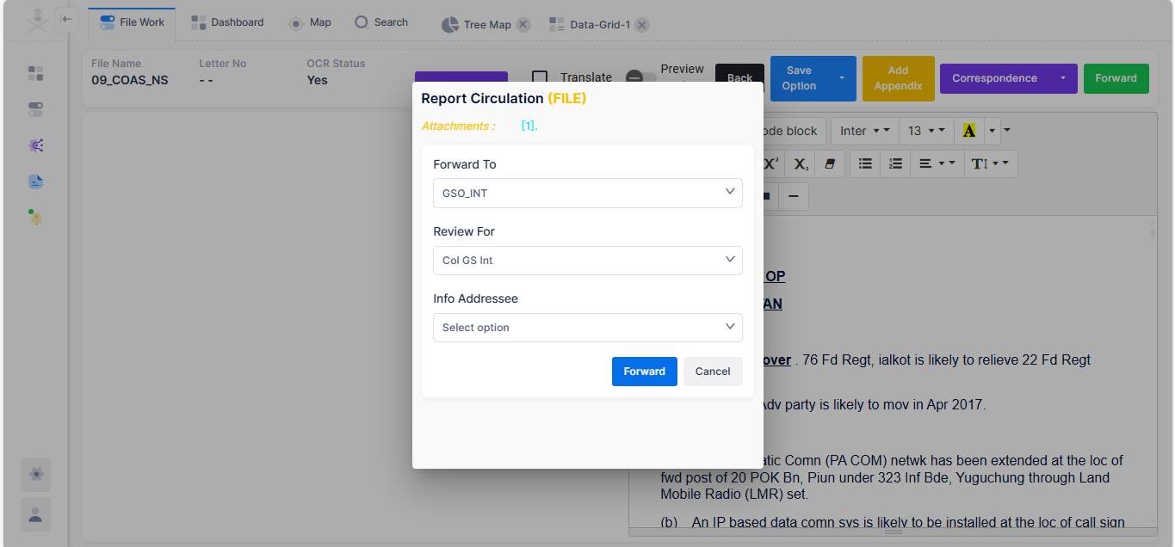

*Figure 4-4.1: Workflow Automation: Report Ingestion and forward for review interface.*

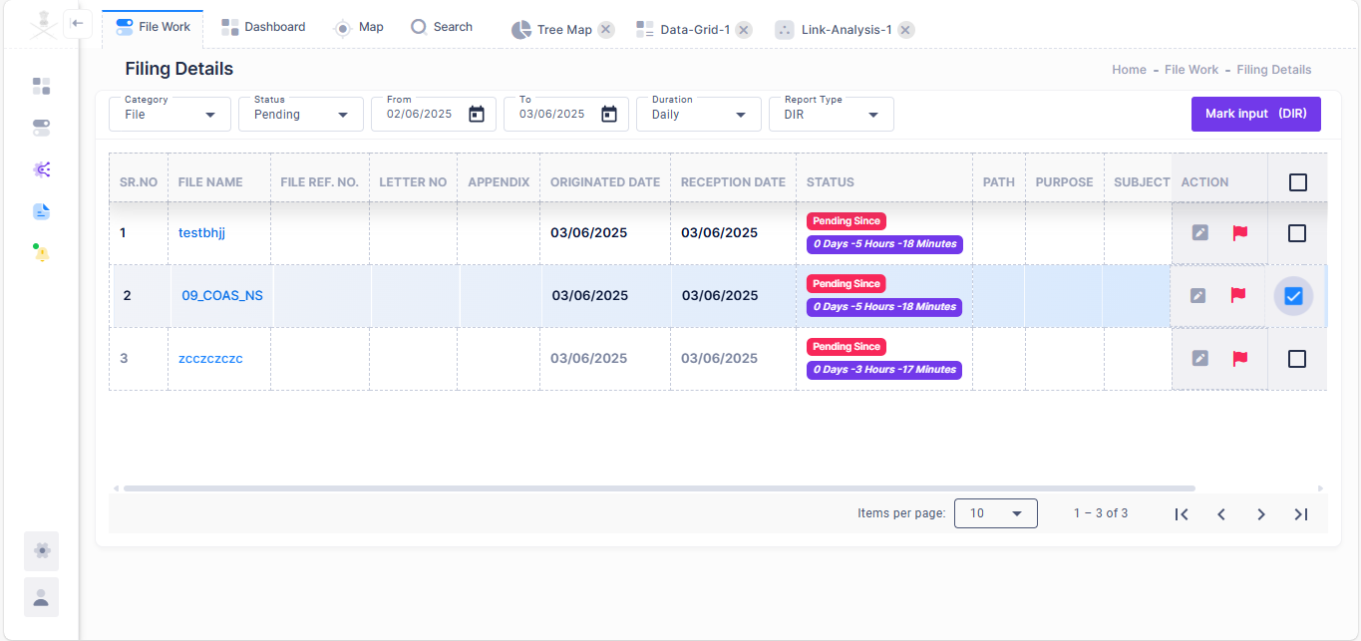

*Figure 4-4.1: Workflow Automation: Report review & approval interface.*

* **Data Flow Description:**

1. **Define Workflow:**
   * The Clerk accesses the "File Work" interface.
   * The Clerk successfully ingest the multiple files into the system.
   * The Clerk will forward the uploaded source file to second higher designation.
   * Second designated user chooses relevant data from it, to generate the reports and mark it to the approver.
   * The approver may recommend edits, or forward input as is to higher designation.
2. **Workflow Execution (System/Trigger):**
   * When a defined trigger occurs (e.g., new data ingested, or approval submitted), the system automatically initiates the workflow.
   * The system executes each stage sequentially, passing the output of one stage as the input to the next.
   * During execution, the system logs the progress and status of each stage.
3. **Review and Approval (Workflow Approver):**
   * When a workflow reaches an approval stage, the designated Workflow Approver is notified.
   * The Approver accesses a "File Work" module and select type of report in Category option that will display associated file list. To review a file, approver will click on the file name, which open a RHS window, in which Approver navigate to the ‘details’ section, where Approver must click on the ‘Reference File’ marked in ‘OCR file path’, to review that file in the new browsing tab.
   * The Workflow Approver reviews the data/output and either approves or rejects it.
   * **If Approved:** The workflow proceeds to the next stage.
   * **If Rejected:** The workflow either stops, reroutes to a previous stage for correction, or triggers an alert for manual intervention, as defined in the workflow.
4. **Report Generation:**
   * Upon successful completion of the workflow (or at a defined reporting stage), the Approver generates reports based on the workflow's outcomes.
   * Reports are stored or distributed as configured.
5. **Monitor Workflow Status:** The Clerk (and potentially others) can monitor the status of running and completed workflows through a dashboard, viewing current stage, progress.

**Postconditions:**

* Data is processed automatically according to defined business logic.
* Manual review and approval points ensure data quality and compliance.
* Reports are generated based on processed information.

**4.5 Module: Geospatial Analysis Module (FR-GIS-001)**

* **Overview:** Interactive map displaying geospatial data, with filtering and layering options.
* **Key Screens/Interfaces:**

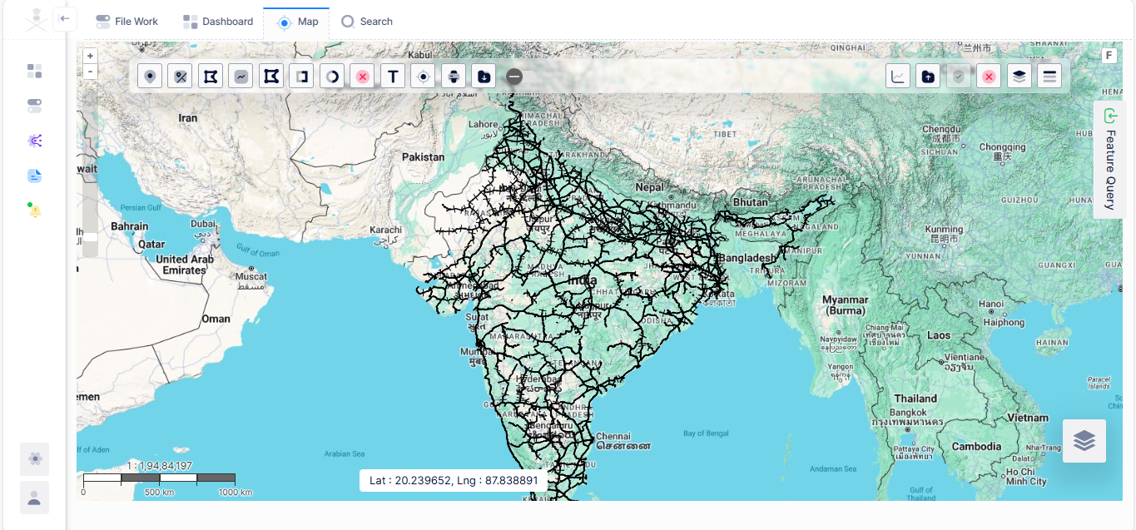

*Figure 4-5.1: Geospatial Analysis: Showing Indian railways track on map.*

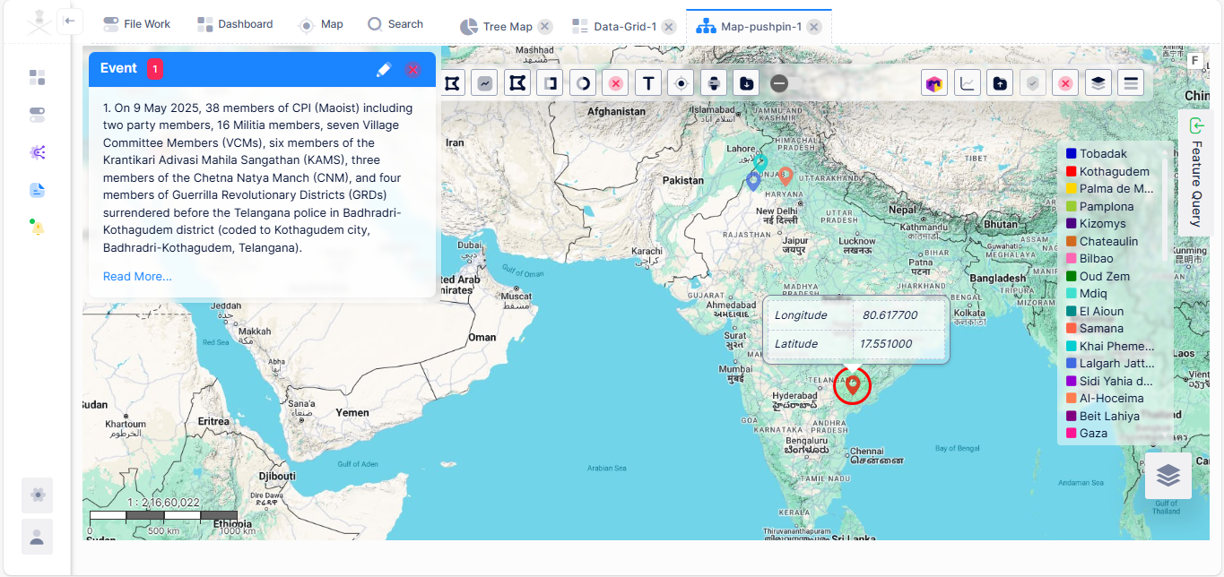

*Figure 4-5.2: Geospatial Analysis: Map pushpins with details.*

* **Data Flow Description:**

1. **Access GIS Dashboard:** The user navigates to the "Map" module.
2. **Display Base Map:** The system loads a base map (e.g., google map, satellite imagery).
3. **Plot Geospatial Data:** The system automatically plots available geospatial data points (e.g., event locations) from the repository onto the map.
4. **Manage Map Layers:**
   * The user can select different map layers (e.g., vector layer, raster layer) to overlay on the base map.
   * The user can toggle the visibility of various data sets plotted on the map.
5. **Filter Geospatial Data:**
   * The user uses on-map controls or a side panel to filter the displayed data based on attributes (e.g., event date, classification, subtype).
   * The map updates on user action to reflect the filtered data.
6. **Interact with Map Elements:**
   * The user clicks on a plotted point or area to view detailed information (e.g., event date, classification, subtype).
   * The user can select multiple points to perform aggregate analysis.
7. **Plot Custom Elements:**
   * The user can manually add custom points, define areas (e.g., polygons for area of interest), or draw routes directly on the map.
   * These custom elements can be ingested, saved and exported (in kml, shp and csv formats).
8. **Geo-Fencing and Geo-Search:**
   * User can mark the particular area of interest as shapes (like polygon, circle, square) to filter (events, raster, vector layers) and search the data accordingly for specific map type (cluster, pushpin, bubbles).
9. **Geo-Temporal Analysis:** The system should create a timeline layer on top of the geo-layer to determine the temporal-geospatial relationship.
10. **Visualize Reports/Analysis:** The system can overlay visual representations of reports or analytical findings that have a geospatial component (e.g., heatmaps of activity, clusters, pushpins, timeline, synchronisation maps).

**Alternative Flows:**

* **No geospatial data:** The map loads but indicates no plottable data.

**Postconditions:**

* Users have an intuitive visual understanding of location-based data.
* Geospatial data can be analyzed and understood in context.

**4.6 Module: Temporal Analysis Module (FR-TIM-001)**

* **Overview:** Interactive timeline for plotting and exploring multiple events chronologically.
* **Key Screens/Interfaces:**

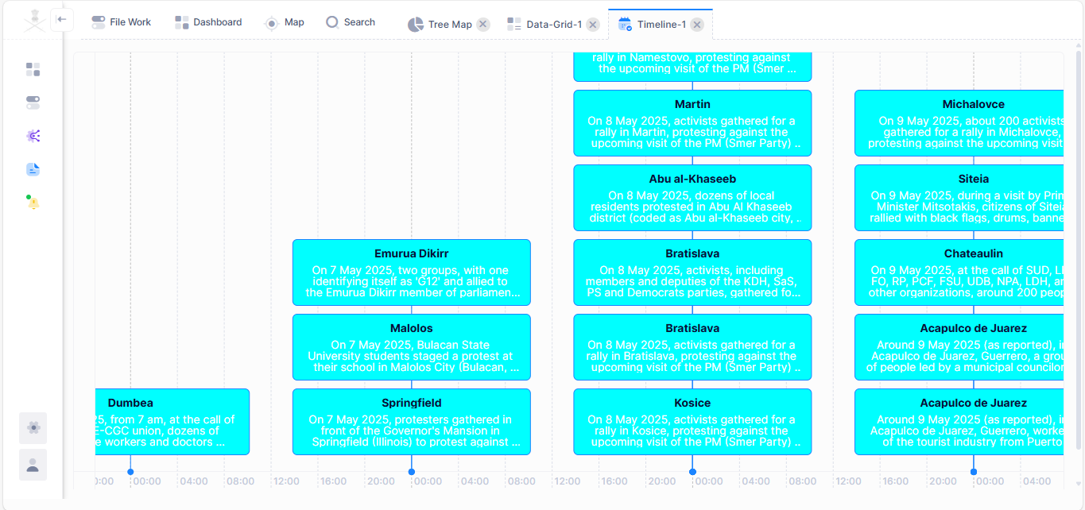

*Figure 4-6: Temporal Analysis: Plotted multiple events chronologically.*

* **Data Flow Description:**

1. **Access Timeline Module:** To access the "Timeline" module, user must perform a Global Search, and in the search result if ‘Events’ are presents, then open this index by double click on it. Now select the specific number of records and add them to timeline (via right context menu), a new tab with title ‘Timeline’ will plot all these events in a timeline view.
2. **Plot Events on Timeline:** The user has to input event date, subject, description, and colour & instance (optional). Post that ‘Show Timeline’ button will be visible to renders the selected events on a chronological timeline, with events marked at their respective timestamps.
3. **Navigate Timeline:**
   * The user can zoom in and out on the timeline to view different time granularities (e.g., hourly, daily, monthly, yearly).
   * The user can pan along the timeline to move through different time periods.
   * The user can filter events by date range or other attributes directly on the timeline.
4. **View Event Details:** When the user clicks or hover on an event marker on the timeline, a detailed tooltip displays information about that specific event (e.g., full text).
5. **Compare Events:** The system allows for viewing multiple types of events simultaneously on the same timeline, enabling comparison and identification of correlations.

**Alternative Flows:**

* **Overlapping events:** The timeline gracefully handles multiple events occurring at the same or very close times (e.g., stacking).

**Postconditions:**

* Users can visually identify patterns, trends, and anomalies over time.
* Temporal relationships between disparate events become apparent.

**4.7 Module: Graph Analysis Module (FR-GRPH-001)**

* **Overview:** Dynamic graph visualization for exploring relationships between data entities.
* **Key Screens/Interfaces:**

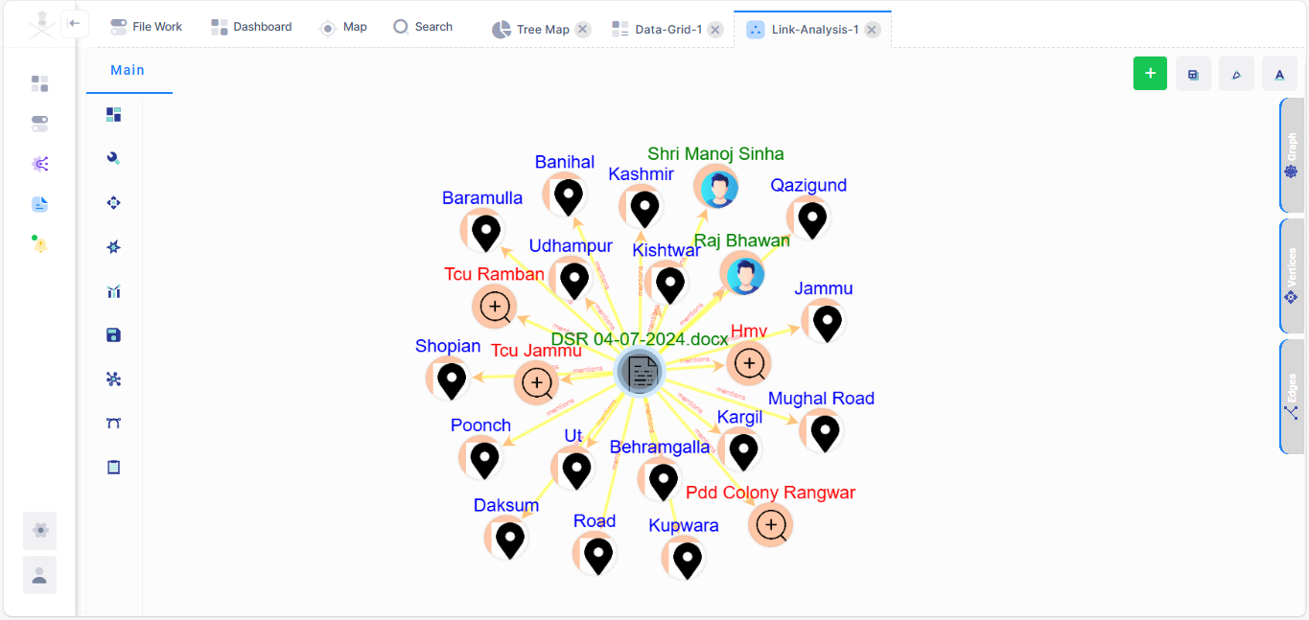

*Figure 4-7: Graph Analysis: visualise relationships between entities (person, location, document).*

* **Data Flow Description:**

1. **Access Graph Module:** To access the "Graph" module, user must perform a Global Search, and in the search result if ‘Events’ are presents, then open this index by double click on it. Now select the specific number of records and add them to ‘Link-Analysis’ (via right context menu), a new tab with title ‘Link-Analysis’ will plot all these events in a graphical view.
2. **Load Graph:**
   * Automatically: The system plots the graph automatically post user trigger.
   * Explode by Relation Node: User must define the criteria such as relationship type like explode by person, location, unit to plot the graph.
3. **Initial Graph Visualization:** The system renders an interactive graph where data points are represented as nodes and relationships as edges.
4. **Explore Connections:**
   * The user can click on a node to view its immediate connections and associated properties in the RHS panel.
   * The user can expand a node to reveal its connected nodes and their relationships, extending the graph view.
5. **Apply Layouts:** The user can select different graph layout (e.g., spread, circular) to optimize the visual representation for better understanding.
6. **Interact with Graph Elements:** The user can drag nodes, zoom in/out, and pan across the graph to explore different sections.
7. **Save Graph Views:** The user can export specific graph views for future reference or sharing.

**Alternative Flows:**

* **No relationships found:** The system displays individual nodes but indicates no relationships if the selected data is not interconnected.

**Postconditions:**

* Users gain a visual understanding of complex relationships within the data.
* Hidden patterns and connections are revealed through interactive exploration.

**4.8 Module: Widgets (FR-WGT-001)**

* **Overview:** Customizable dashboards with various widgets (charts, summaries).
* **Key Screens/Interfaces:**

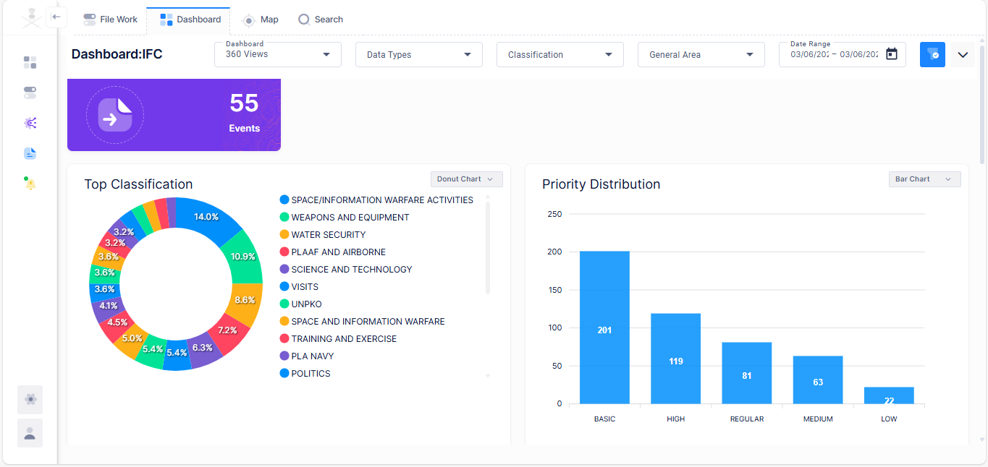

*Figure 4-8: Widgets: Dashboards with various widgets.*

* **Data Flow Description:**

1. **Access Dashboard Customization:** The user navigates to their personal dashboard or a shared dashboard they have permission to customize.
2. **Browse Widget Catalogue:** The user clicks an "Add Widget" button, revealing a catalogue of available widgets.
3. **Select and Add Widget:** The user selects a desired widget type (e.g., "Bar Chart", “GIS”) or filter it using specified criteria.
4. **Configure Widget:**
   * **For data-driven widgets (charts):** The user selects the data source, metrics, and dimensions to display. They may also configure chart types, colors, and titles.
   * **For informational widgets (maps, cards):** The user may configure the content or source of the information.
5. **Place and Resize Widget:** The newly added widget appears on the dashboard. The user can drag and drop it to rearrange its position and resize it to fit their layout.
6. **Remove Widget:** The user can select an existing widget and choose to remove it from the dashboard.
7. **Rearrange Widgets:** The user can drag and drop widgets to change their order and layout on the dashboard.
8. **Save Dashboard Layout:** The system automatically saves the user's dashboard layout and widget configurations.

**Postconditions:**

* User has a personalized dashboard tailored to their information needs.
* Key information and analysis are readily visible upon logging in.

**4.9 Module: Report Generation (FR-RPT-001)**

* **Overview:** To enable users to generate comprehensive reports in various formats based on defined criteria or workflow outcomes and manage these reports.
* **Key Screens/Interfaces:**

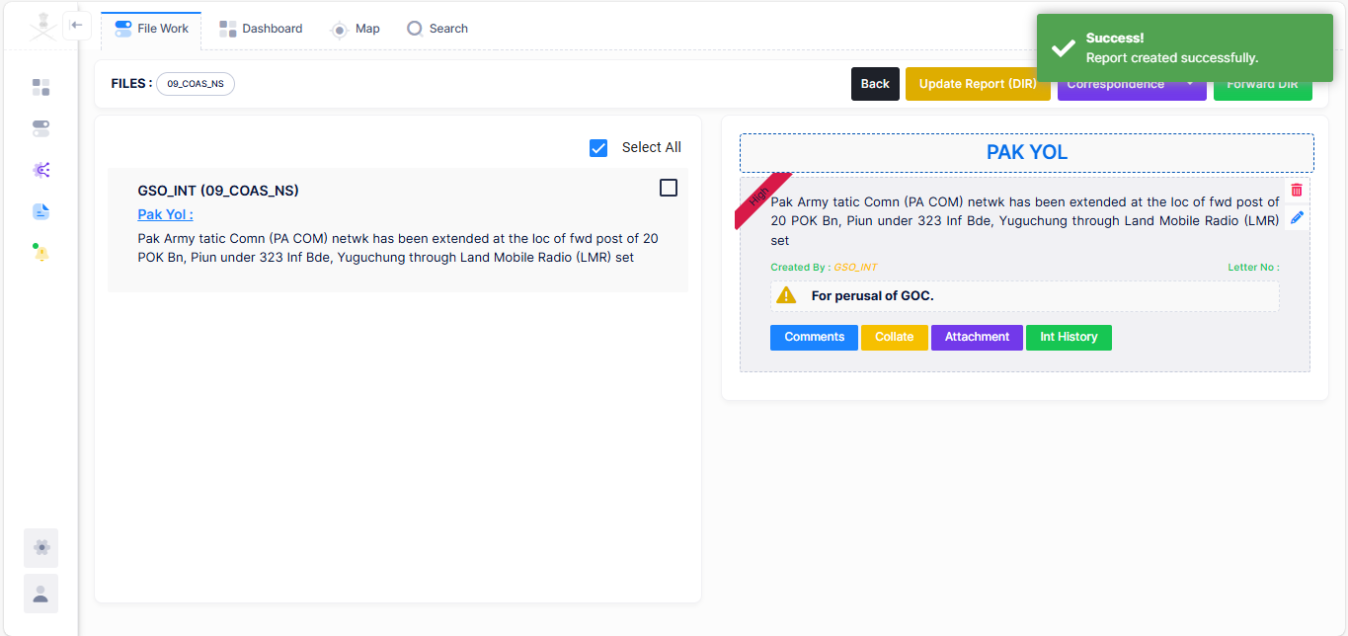

*Figure 4-9.1: Report Generations through workflow automation.*

*Figure 4-9.2: Report Generations from the searched data.*

* **Data Flow Description:**

1. **Report Generation for Workflow Automation:**
   * The Clerk accesses the "File Work" interface.
   * The Clerk successfully ingest the multiple source files into the system.
   * The Clerk will forward the uploaded source file to second higher designation.
   * Second designated user chooses relevant data from it, to generate the reports and mark it to the approver.
   * The approver may recommend edits, or forward input as is to higher designation.
   * Upon successful completion of the workflow, the Approver generates reports based on the workflow's outcomes.
   * Reports are stored or distributed as configured.
2. **Report Generation from the Search Data:** To generate such report user must export the grid-data into a desired output format for the report (Word, Excel, PDF, XML, HTML).
   * The system processes the data based on the criteria, applies the chosen format, and generates the report file.
3. **Manage Generated Reports through the Workflow Automation:**
   * The system stores the generated report in a central repository.
   * The user can access a "File Work" module to view a list of all generated reports.
   * From this interface, the user can view, download, or archive reports.

**Alternative Flows:**

* **Report generation failure:** If report generation fails (e.g., due to data errors), the system logs the error and notifies the user.
* **Large report size:** The system handles large reports efficiently, potentially offering options for background generation and notification upon completion.

**Postconditions:**

* Reports containing relevant data are generated in desired formats.
* Reports are easily accessible and manageable.

**4.10 Module: AI/LLM Model (FR-LLM-001)**

* **Overview:** Provide more intuitive search and powerful summarization capabilities for ingested data.
* **Key Screens/Interfaces:**

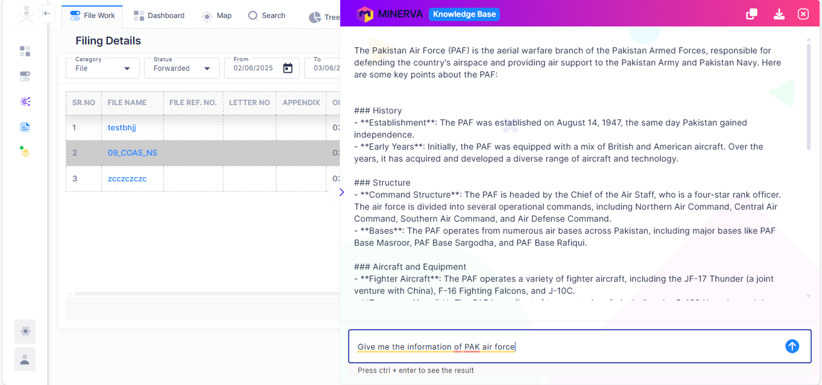

*Figure 4-10.1: AI/LLM Module: Knowledge Base.*

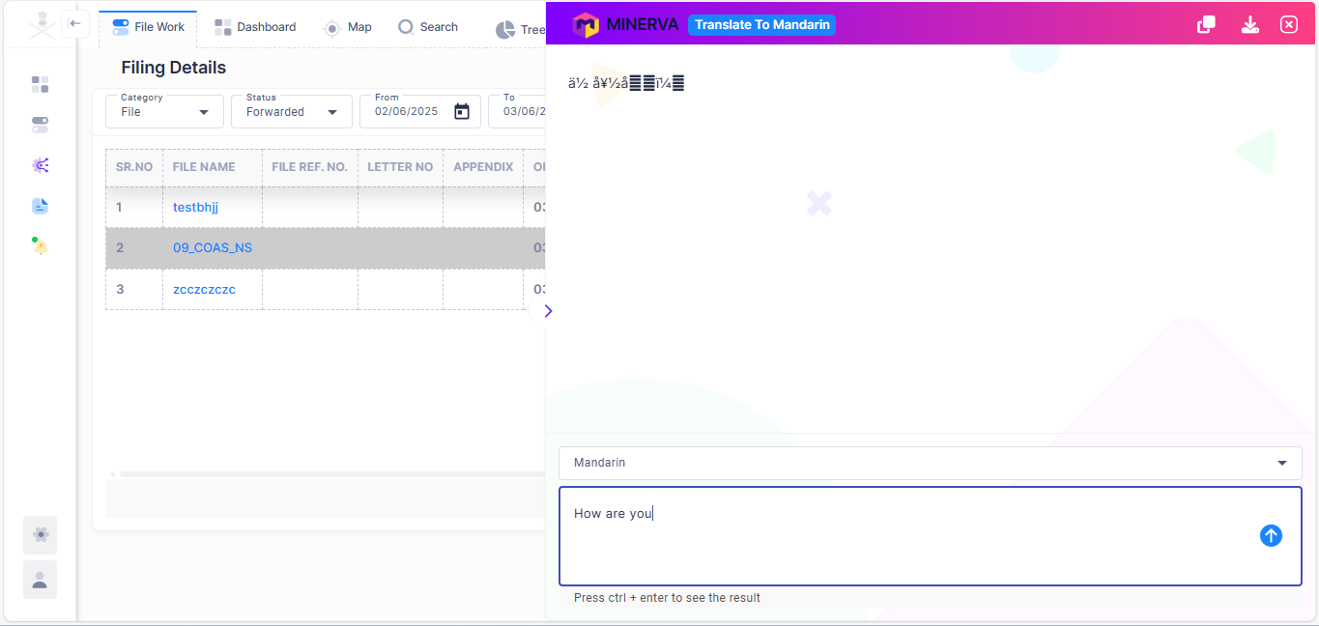

*Figure 4-10.2: AI/LLM Module: Language Translations.*

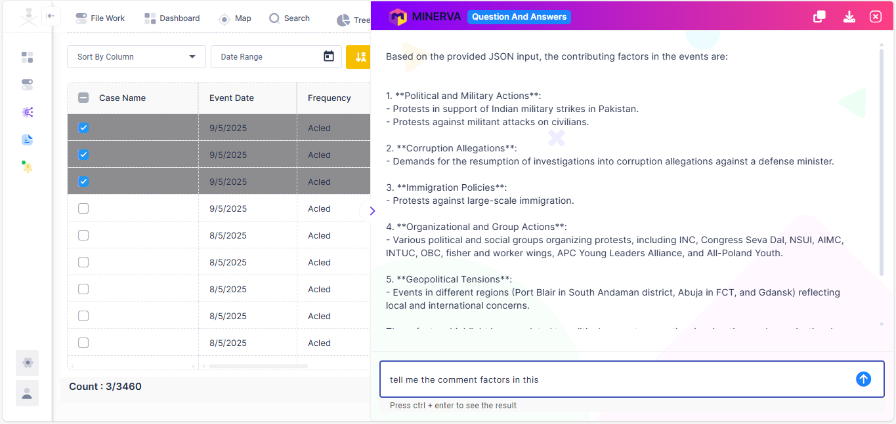

*Figure 4-10.3: AI/LLM Module: Questions & Answer Interface.*

* **Data Flow Description:**

1. **Enhanced Natural Language Search and Q&A:**
   * The user navigates to the search interface to search a keyword of interest, which will render a list of indexes. From these indexes user can navigate to desired data view, where he/she can select the records on which he/she wants to AI/LLM module.
   * Here user types a natural language question (e.g., "Give the list of training locations of each unit?").
   * The system passes the query to the LLM.
   * The LLM processes the query, understands the intent, and retrieves relevant information from the underlying data.
   * The LLM synthesizes an answer in natural language, citing sources from the ingested data.
   * The answers are displayed to the user and can be copied or exported.
2. **Summarize Events/Documents:**
   * The user selects one or more documents, events (from timeline), or profiles (e.g., individual, organization, unit) from the system interface.
   * The user initiates a "Summarize" action.
   * The system sends the selected content to the LLM.
   * The LLM analyzes the content and generates a concise summary.
   * The summary is displayed to the user and can be copied or exported.
3. **AI Predictions:**
   * The user selects one or more documents, events (from timeline), or profiles (e.g., individual, organization, unit) from the system interface.
   * The user initiates an "AI Predictions" action.
   * The system sends the selected content to the LLM.
   * The LLM analyzes the content and generates a concise prediction.
   * The prediction is displayed to the user and can be copied or exported.
4. **Knowledge base** 
   * User can access this feature through the right-hand side menu option, named ‘AI/LLM’, and its submenu having title *Knowledge Base.*
   * Here user types a natural language question (e.g., "Give me the name of the permanent member countries of BRICS?").
   * The system passes the query to the LLM.
   * The LLM processes the query, understands the intent, and retrieves relevant information from the underlying data.
   * The LLM synthesizes an answer in natural language, citing sources from the ingested data.
   * The answers are displayed to the user and can be copied or exported.
5. **Translate/Transliterate:**
   * User can access this feature through the right-hand side menu option, named ‘AI/LLM’, and its submenu having title *Translate or Transliterate.*
   * Here user can provide the text contents to be translated in desired languages like Mandarin, Urdu, Arabic, Hindi, English, Punjabi.
   * The system passes the query to the LLM.
   * The LLM processes the text, understands the intent, and retrieves relevant information from the underlying data.
   * The LLM synthesizes an answer in translated natural language.
   * The translated text will be displayed to the user that can be copied or exported.

**Alternative Flows:**

* **Insufficient information:** If the LLM cannot find enough relevant information to answer a question or summarize, it informs the user.

**Postconditions:**

* Users can interact with the data using natural language.
* Complex information from multiple sources can be quickly summarized.
* Search results are more contextual and direct.

**4.11 Module: Predictive Module (FR-PRD-001)**

* **Overview:** To allow a user to access predictive generations and pattern reorganisations based on historical data and generate predictions for various scenarios.
* **Key Screens/Interfaces:**

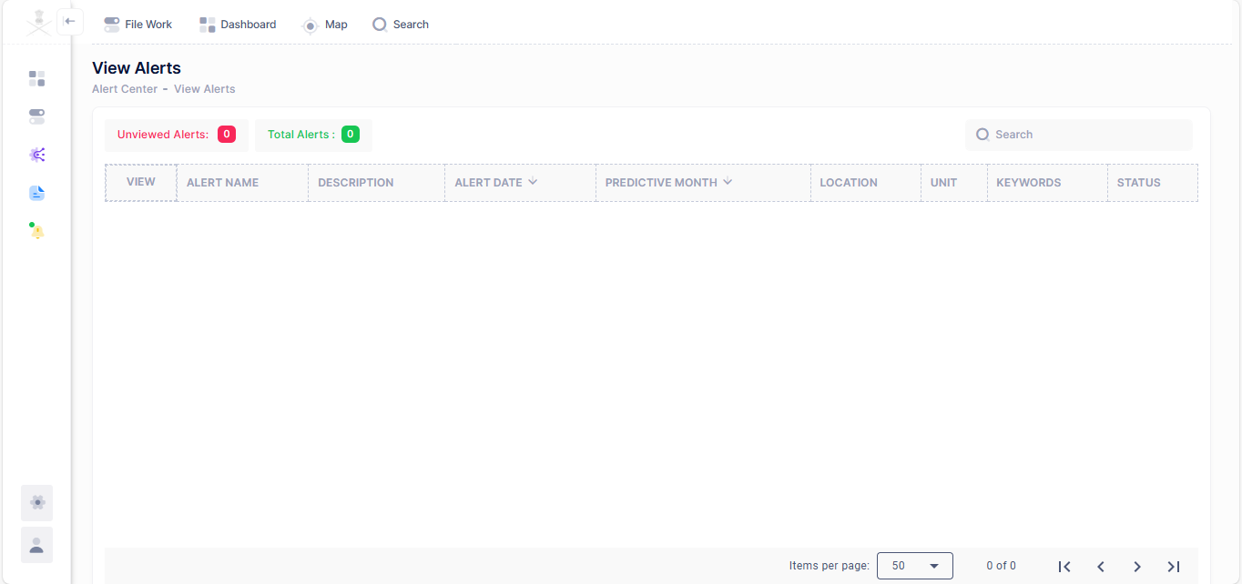

*Figure 4-11: Predictive Module: Alerts.*

* **Data Flow Description:**

1. **Access Predictive Module:** The designated user logs into the system and navigates to the "Predictive Alerts" or "Predictive Module" section.
2. **Configure Prediction Model:**
   * **Data Selection (FR-PAN-001.4):** The user specifies the relevant historical data sources (from the Big Data Repository) to be used for the prediction, ensuring data spans the last three years.
   * Pattern Recognition Configuration (FR-PAN-001.2): The system configures parameters for the pattern recognition algorithms (e.g., temporal windows, locations).
   * Trend Identification Configuration (FR-PAN-001.5): The system uses parameters to identify trends from the historical data (e.g., likely hotspots of infiltrations, likely locations of units for training).
   * Prediction Scenario Mapping (FR-PAN-001.6): The user links the identified trends and patterns to the specific prediction types (e.g., "infiltration events" lead to "likely hotspots for infiltration").
   * AI based Model Parameters (FR-PAN-001.7): The system implicitly uses a mathematical model based on probabilities to deliver emergent patterns, probability scores of events, locations etc.
3. **Train/Build Prediction Model (System):** The system processes the selected historical data, identifies patterns and trends, and builds/optimizes the predictive model based on the defined Use Case parameters and mathematical model.
4. **Generate Predictions (FR-PAN-001.1, FR-PAN-001.6):**

* The system triggers the prediction generation for the configured Use Case.
* The system applies the trained model to current or future-projected data.
* Predictions are generated for the specific scenarios (e.g., "Likely hotspots for infiltration," "Units which may go for training or move," "Likely hotspots (concentration) of radars").

1. **View and Analyze Predictions:**

* The system displays the generated predictions, potentially on relevant dashboards (e.g., GIS dashboard for hotspots, timeline for unit movements).

**Postconditions:**

* Predictions for specific scenarios are generated and available for viewing and further analysis.
* The system has performed pattern recognition and trend identification based on historical data.

**4.12 Module: IMINT Module (FR-IMT-001)**

* **Overview:** To enable users to ingest Imagery Intelligence (IMINT) data from various sources into a standardized, form-based collation system.
* **Key Screens/Interfaces:**

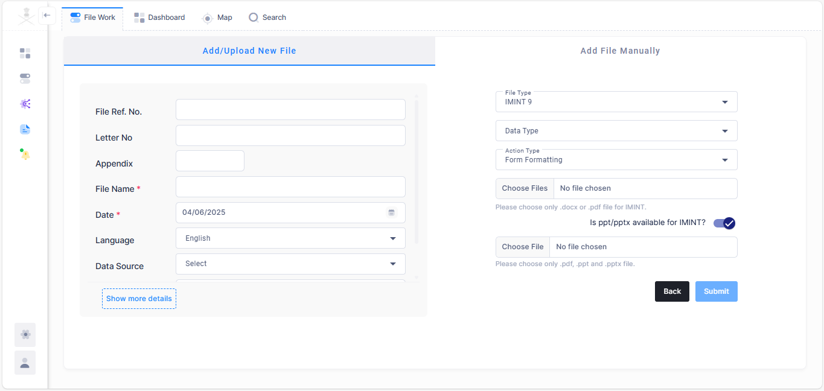

*Figure 4-12: IMINT Module.*

* **Data Flow Description:**

1. The user navigates to the "File Work" module and click on the ‘Create’ button for data ingestion. Add the mandatory fields like file, name, report date, file type for the datasets (file) you wish to ingest.
2. **Configure Pipeline:**
   * **For File-based sources:** The user specifies the file path(s) or directory, file naming conventions.
   * **Select Source Type:** The user chooses the data source type from a list:
     + Scanned Documents (FR-ING-001.4)
     + Digital Document Files (e.g., PDF, Word, PPTX) (FR-ING-001.5)
3. **Execute Ingestion:**
   * The user clicks "submit" to initiate the ingestion process immediately.
   * The system implicitly maps the ingested data to the Big Data Repository.
4. **Ingestion Status:** The system displays a fadeout message with ingestion results.
5. **Address Errors (if any):** If failures occur, the user can review the logs, identify the root cause, and take corrective actions (e.g., correct source data) and re-run the ingestion.

**Postconditions:**

* Relevant IMINT data is successfully ingested and stored within the form-based collation system.
* The IMINT Ingestion Dashboard provides visibility into recent ingestion activities.